

Software Engineering
Software Requirements Specification
(SRS) Document

Andrew Doyle
Chad Sloan
Stephanie Shaver
Ethan Bowyer
Software Engineering I
www.radford.edu/~team14
March, 23, 2011

Revisions

Version | Primary Author(s) | Description of Version | Date Completed
Rough Draft Version 1 | Team 14 (Chad Sloan, Ethan Bowyer, Andrew Doyle, Stephanie Shaver) | Completed Introduction | 03/21/11
Final Draft  Version 2 | Team 14 (Chad Sloan, Ethan Bowyer, Andrew Doyle, Stephanie Shaver) | Completed all the sections | 03/23/11

Review & Approval
Requirements Document Approval History

Approving Party | Version Approved | Signature | Date
Project Manager
Dr. T. L. Lewis

Requirements Document Review History

Reviewer | Version Reviewed | Signature | Date
Andrew Doyle | 2
Chad Sloan | 2
Stephanie Shaver | 2
Ethan Bowyer | 2

Contents

1. Introduction 4
1.1 Purpose of this document 4
1.2 Scope of this document 4
1.3 Overview 4
1.4 Business Context 4
2. General Description 4
2.1 Product Functions 4
2.2 Similar System Information 5
2.3 User Characteristics 5
2.4 User Problem Statement 5
2.5 User Objectives 5
2.6 General Constraints 5
3. Functional Requirements 6
4. Interface Requirements 11
4.1 User Interfaces 11
4.2 Hardware Interfaces 13
4.3 Communications Interfaces 13
4.4 Software Interfaces 13
5. Performance Requirements 13
6. Other non-functional attributes 14
6.1 Security 14
6.2 Binary Compatibility 14
6.3 Reliability 14
6.4 Maintainability 14
6.5 Portability 14
6.6 Extensibility 14
6.7 Reusability 14
6.8 Application Affinity/Compatibility 15
6.9 Resource Utilization 15
6.10 Serviceability 15
7. Operational Scenarios 15
8. Preliminary Use Case Models and Sequence Diagrams 15
8.1 Use Case Model 16
8.2 Sequence Diagrams 16
9. Updated Schedule 17
10. Updated Budget 18
11. Appendices 18
11.1 Definitions, Acronyms, Abbreviations 18
11.2 References 18

1. Introduction
1.1 Purpose of this document
The purpose for this document is to highlight the specific requirements of the Content Management System that the CodeWalkers are developing for the Sports Club Council. Within the document we will give specifications for the functional, interface, performance, and non-functional requirements. The intended audience for this document is the CodeWalkers team~~~~~
1.2 Scope of this document
The scope of this document mainly pertains to the CodeWalkers team as reference and guideline for the requirements we plan to implement for the Sports Club Council’s Content Management System. The requirements elicitation team consists of the CodeWalkers team as well as our customer, Mr. Foster Ridpath.
We currently have not placed any constraints on the requirement elicitation process.
1.3 Overview
The final deliverable for this project is to provide a fully operational content management system for the Sports Club Council. Some functionalities of this system are the ability for the specific Sports Clubs to add content easily to the sports club website. The content that is uploaded by the specific club should not be able to be modified by any other user besides the administrator. Content that clubs shall be able to upload includes pictures, event posts, as well as calendar entries.
1.4 Business Context
The Sport’s Club Council will utilize the Joomla! Content Management System as a means of posting articles of recent sports events as well as uploading photos of those events. The council will also utilize a calendar to inform users of upcoming sports events.

2. General Description
2.1 Product Functions
We will develop a content management system for the Sports Club Council that can be accessed via the World Wide Web. Certain individuals (referred to as users) in the sports club council will be able to use their Radford user name and password to log into the system. Users will be able to use an interactive calendar to post the dates of upcoming sports events. They may also post articles about sporting events that first be submitted to the administrator; with the approval of the administrator the article will then be shown publicly. The main page will also allow users to post short messages about recent news, such as the score of a recently finished game. Users may also submit pictures which will be grouped with their respective sports.
The system will also include a list of the clubs that are in the Sports Club Council, along with links to each individual clubs respective web sites. It will also include the names and contact information of all officers within the Sports Club Council, as well as the names and contact information of each of the officers in the various clubs that make up the Sports Club Council. Various forms used by the Sports Club Council will also be stored in the content management system, such as the Sports Club Handbook and the Fundraiser forms.

2.2 Similar System Information
VCU’s Sports Club Council has a couple of similar features to the features we plan on implementing. On their main page they have a section to post recent news about their various clubs and news about recent sports events. However this differs from our implementation in the fact that they are combining the two whereas we separate articles from events from recent news posts.
The UNC Sports Club Council replicates our plan of implementation accurately. On the main page, they have news posting section and a neat assortment of photos and albums organized by sports and events.
2.3 User Characteristics
The user community shall be made up of Mr. Foster Ridpath, and the various members of the clubs that make up the Sport’s Club Council. The expected expertise shall include basic computer skills, such as navigation of a web page, familiarity with uploading files, as well as posting and editing text.
2.4 User Problem Statement
The current Sport’s Club Council updates its information by having the clubs email Mr. Foster Ridpath the information or photos for him to upload onto the website, which takes space on his own hard drive and delays the information from being posted. The site also needs an organized place to upload the photos, because the way it is currently the photos are scattered on the page. The current site is also out of date and it doesn’t list upcoming events. The site has no way other the web administrator to log into the system.
2.5 User Objectives
The objectives for the new Sport’s Club Council, clubs shall be able to use their Radford user name and password to log into the system. Clubs shall to be able to view upcoming events from a calendar. The main page will also allow clubs to post short messages about recent news, such as the score of a recently finished game. Clubs shall be able to submit pictures which will be grouped with their respective sports.
2.6 General Constraints
Our system design team is restricted to using the content management system “Joomla!” As an industry protocol, the design team is restricted to using the Radford University color scheme. Our team is constrained by being able to work on this project for only a single semester.
3. Functional Requirements
- User Login
  - The user shall be able to login into the system.
  - Criticality: 5
  - The user shall already have to have been registered into the system. The user shall provide the login interface with their user name and password.
  - The user might not have their password memorized, thus the system shall have to provide a password recovery.
  - This requirement is dependent on the Club Registration functional requirement.

- Administrator Backend Login
  - The Administrator shall be able to login to the system from the backend.
  - Criticality: 5
  - Joomla comes installed with this feature, so it is automatically implemented.
  - The administrator could forget the password and not be able to login. This can be resolved by providing password recovery.
  - This requirement has no dependencies

- Club Registration
  - An Administrator shall be able to register a club with the system.
  - Criticality: 4
  - A club shall have to provide information
  - A user might provide the system with false information, thus an administrator shall be able to review the information provided. Or the system will provide an activation measure or a password (for which the user shall be able to change later) in the email provided at registration.
  - None

- Password Recovery
  - The system shall be able to give a user their password when requested by that user.
  - Criticality: 4
  - The system shall be able to send an email to the user with their password when it is requested by that particular user. Another implementation is to have a secret question and answer in which the user shall be able to answer for their password
  - A user may forget their email password or secret answer.
  - This requirement is dependent on the Club Registration and User Login functional requirements.

- User logout
  - The user shall be able to logout of the system
  - Criticality: 3
  - The user shall be able to logout of the system by a logout function available on each page accessible by the user.
  - The user may close out of the web page without logging out with the logout function, thus the system should automatically log a user out within a certain amount of being inactive.
  - This requirement is dependent on the Club Registration and User Login functional requirements.

- Delete Clubs
  - The administrator shall be able to delete clubs from the system.
  - Criticality: 3
  - Joomla comes with this feature already installed, so it is automatically implemented.
  - A club could be deleted accidently. This will be solved by only allowing clubs to be deleted by Administrators.
  - This requirement is dependent on Club Registration and Administrator Backend Login.

- Create Album
  - All users shall be able to create an album to store pictures in.
  - Criticality: 3
  - A Joomla plugin may be necessary in order to implement albums.
  - The Joomla plugin could be very difficult and time constraining to implement. This can be solved by not procrastinating and by looking at many different kinds of plugins that can accomplish this task.
  - This requirement is dependent on the Club Registration and User Login functional requirements.

- Create Calendar Event
  - The user shall be able to create events in the calendar.
  - Criticality: 3
  - A Joomla plugin will be necessary in order to implement a calendar.
  - The plugin could be difficult to implement. Some events may also conflict based on duplicate dates or times. This risk could be prevented by no procrastinating and thoroughly assessing the pros and cons of all calendar plugins available.
  - This requirement is dependent on Club Registration as well as a calendar plugin implementation and the User Login functional requirement.

- Add Photo
  - The user shall be able to add photos to a specified album.
  - Criticality: 3
  - A photo album must be present in order to add a photo to be displayed.
  - A club could add a photo to an album posted by another club. To prevent this we must set up permissions to prevent clubs from adding photos to albums that are not theirs.
  - This requirement is dependent on User Login and Club Registration as well as the create album functional requirement.

- Delete Photo
  - The administrator shall be able to delete photos from an album.
  - Criticality: 3
  - A photo album and a photo must be present in order to delete a photo.
  - A club could delete a picture posted by another club. To prevent this we must set up permissions to prevent clubs from deleting photos that are not theirs. Another possibility could be that a prompt would alert the administrator as to whether or not they really want to delete that photo.
  - This requirement is dependent on Administrator Backend Login, Club Registration, the Create Album and the Add Photo functional requirements.

- Add Post
  - A user shall be able to add a post about what is currently going on at an event for all other users to see.
  - Criticality:3
  - Requires Joomla! News Feed plug-in in order to allow users to add posts.
  - An unauthorized person could add a post containing irrelevant data. This can be solved by only allowing clubs that are registered in the system to post.
  - This requirement will depend on the User Login requirement as well as Club Registration.

- Delete Post
  - An administrator shall be able to delete a post that has been added to the news feed.
  - Criticality: 3
  - Requires Joomla! News Feed plug-in that allows users to remove their own posts.
  - A club could delete a post from another club. This can be solved by setting up permissions so that a club cannot delete a post that is not theirs.
  - This requirement will depend on the Administrator Backend Login and Add Post functional requirements as well as Club Registration.

- Add Article
  - A user shall be able to add an article to the website after logging in.
  - Criticality: 3
  - Will need to have a Joomla! Posting plug-in that allows users to upload an article they’ve written for other users to see.
  - An unauthorized person could add an article containing irrelevant data. This can be solved by only allowing clubs that are registered in the system to add articles.
  - This requirement will depend on the User Login requirement as well as Club Registration.

- Delete Article
  - An administrator shall be able to remove an article they have uploaded.
  - Criticality: 3
  - Will need to have a Joomla! Posting plug-in that allows users to delete their uploaded article(s).
  - A club could delete an article from another club. This can be solved by setting up permissions so that a club cannot delete an article that is not theirs.
  - This requirement will depend on the Administrator Backend Login and Add Article functional requirements as well as Club Registration.

- Administrator Backend Logout
  - The Administrator shall be able to logout of the backend of the system.
  - Criticality: 2
  - Joomla comes installed with this feature, so it is automatically implemented.
  - The Administrator could become unable to logout. This can be solved by forcing the administrator account to logout if the connection to the system is lost or the administrator is idle for a specific amount of time.
  - This requirement is dependent on Administrator Backend Login.

- Modify Article
  - A user shall be able to modify their uploaded article.
  - Criticality: 2
  - Will need to have a Joomla! Posting plug-in that allows users to modify their uploaded article(s).
  - A club could modify the article of another club. This can be solved by setting up permissions so that a club cannot modify an article that is not theirs.
  - This requirement will depend on the User Login and Add Article requirements as well as Club Registration.

- Modify Post
  - A user shall be able to modify a post that they have added to the news feed.
  - Criticality: 2
  - Requires Joomla! News Feed plug-in that allows users to modify their own posts.
  - A club could modify the post of another club. This can be solved by setting up permissions so that a club cannot modify a post that is not theirs.
  - This requirement will depend on the User Login and Add Post requirements as well as Club Registration.

- Delete Calendar Event
  - The administrator shall be able to delete events from the calendar.
  - Criticality: 2
  - A Joomla plugin will be necessary in order to implement a calendar. A previous event must be present in order to delete an event.
  - A club could delete an event posted by another club. To prevent this we must set up permissions to prevent clubs from deleting events that are not theirs. Another possibility could be that a prompt would alert the administrator as to whether or not they really want to delete that event.
  - This requirement is dependent on Club Registration as well as a calendar plugin implementation. It is also dependent on the create calendar event functional requirement and the Administrator Backend Login functional requirement.

- Modify Calendar Event
  - The user shall be able to modify events in the calendar.
  - Criticality: 2
  - A Joomla plugin will be necessary in order to implement a calendar. A previous event must be present in order to modify an event.
  - A club could modify an event posted by another club. To prevent this we must set up permissions to prevent clubs from modifying events that are not theirs.
  - This requirement is dependent on Club Registration as well as a calendar plugin implementation. It is also dependent on the create calendar event functional requirement and the User Login functional requirement.

- Delete Album
  - The administrator shall be able to delete an album to store pictures in.
  - Criticality: 2
  - A Joomla plugin may be necessary in order to implement albums.
  - The Joomla plugin could be very difficult and time constraining to implement. This can be solved by not procrastinating and by looking at many different kinds of plugins that can accomplish this task.
  - This requirement is dependent on Club Registration, Create Album and the Administrator Backend Login functional requirement.

- Modify Album
  - All users shall be able to modify an album to store pictures in.
  - Criticality: 2
  - A Joomla plugin may be necessary in order to implement albums.
  - The Joomla plugin could be very difficult and time constraining to implement. This can be solved by not procrastinating and by looking at many different kinds of plugins that can accomplish this task.
  - This requirement is dependent on User Login, Club Registration and Create Album.

4. Interface Requirements
4.1 User Interfaces
Describes how this product interfaces with the user.
- 4.1.1 GUI
This is our rough draft for the front end
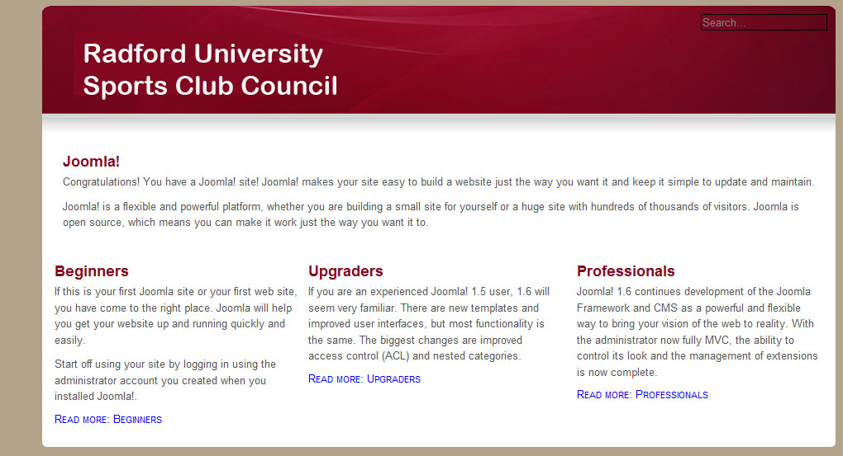

This is the login form on the front end of the website.

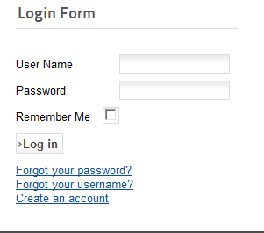

This is the administrator login for the backend of the website.
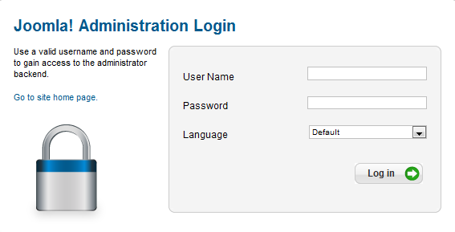

This is the backend of the system, which can only be accessed by an administrator. This section gives the administrator access to many different abilities. These include the ability to add users, edit content on the front end of the site, and even rearrange the layout of the website itself.
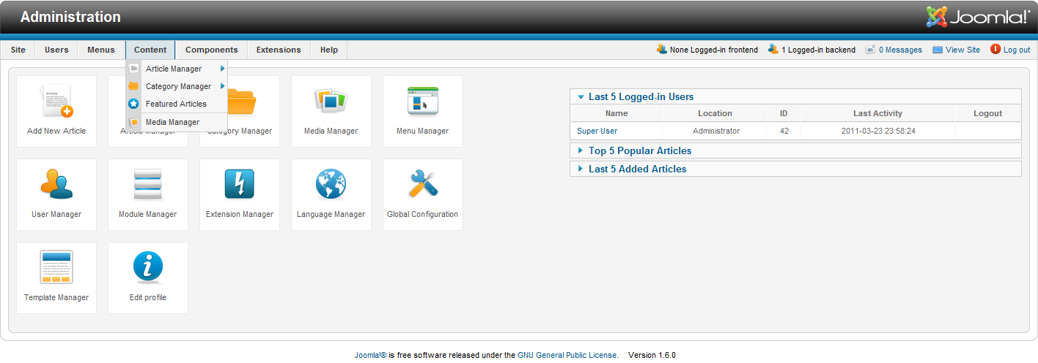

- 4.1.2 CLI
Our system will not have a command line interface present.
- 4.1.3 API
Our system will not have an application programming interface present
- 4.1.4 Diagnostics or ROM
Our system shall not have any debugging software present; however, the system administrator can assess site functionality based on user feedback.
4.2 Hardware Interfaces
Our system does not directly interact with any hardware interfaces. A user shall have an internet ready device with an active internet connection.
4.3 Communications Interfaces
The Content Management System interacts with Radford University’s MySQL server.
4.4 Software Interfaces
A user shall have access to a web browser such as Safari, Firefox, or any others in order to access the system.
5. Performance Requirements
1: An internet speed that is a minimum of 56k
2: Screen resolution that is a minimum of 800 x 600.
3: Should be compatible with any major web browser such as Internet Explorer, Safari, Firefox, Google Chrome.

6. Other non-functional attributes
6.1 Security
Joomla! will be handling login security limited to one key member of each individual club as well as the Sport’s Club Coordinator Mr. Foster Ridpath. Mr. Ridpath will have access to the site as an administrator, whereas the key members of each individual club will have access as super users. The Content Management System is stored on a PHP server secured by Radford University. To ensure club account security, each password is changed on a yearly basis to prevent foul play.

6.2 Binary Compatibility
Our Joomla! Content Management System shall be compatible with all major web browsers that can be used on any major current Operating Systems such as MAC OS , Windows, and Linux/Unix variants.

6.3 Reliability
The Content Management System shall be available at any time Radford University’s PHP server is functioning.
6.4 Maintainability
The website shall be maintained and updated through the Joomla! Content Management System backend.
6.5 Portability
The Sport’s Club Council shall be available to anyone who has an internet connection and a web browser
6.6 Extensibility
This Content Management System shall store photos and have an archive of previous events and articles from previous semesters.
6.7 Reusability
The Administrator of the Content Management System will be responsible for the changing of passwords for each club account every year. He will also be responsible for adding or deleting club accounts as new clubs join or leave the Sports Club Council. Events and posts can also be deleted as needed.
6.8 Application Affinity/Compatibility
The Content Management System shall be accessible to any browser, and not limited it to a specific one.
6.9 Resource Utilization
The Content Management System works with a computer or mobile device that can utilize a web browser and an internet connection.
6.10 Serviceability
The Content Management System shall be well documented so that it can be easily updated in the future if needed.

7. Operational Scenarios
Best Case Scenario: The user shall be able to log into the system using their club username and password without any complications. The user shall then be able to navigate the website by accessing the various menus on the site. The user shall be able to view albums for all clubs, as well as post pictures in his or her club’s album. All of the pictures should be organized in the appropriate album by date. All users shall be able to post comments about sporting events to the main page, and shall be able to view the comments posted by other clubs. Users shall also be able to modify their old posts. All users shall have the ability to post articles about recent sporting events, which will first be submitted to an administrator for review before it is viewable publically. Users shall also be able to view the calendar and the various events on the calendar. They may also post new events on the calendar about upcoming sporting events, or they may modify one of their old event posts.

Worst Case Scenario: The user tries to load up the website, the page will not load, or the user forgets his or her login name or password. The password recovery system fails to deliver the password to the user who requested it. The user who could not log in could only view available information, such as calendar events and photo albums, but this person cannot post or edit any information. Additionally, the calendar entries and photo albums may be out of date.
8. Preliminary Use Case Models and Sequence Diagrams
8.1 Use Case Model
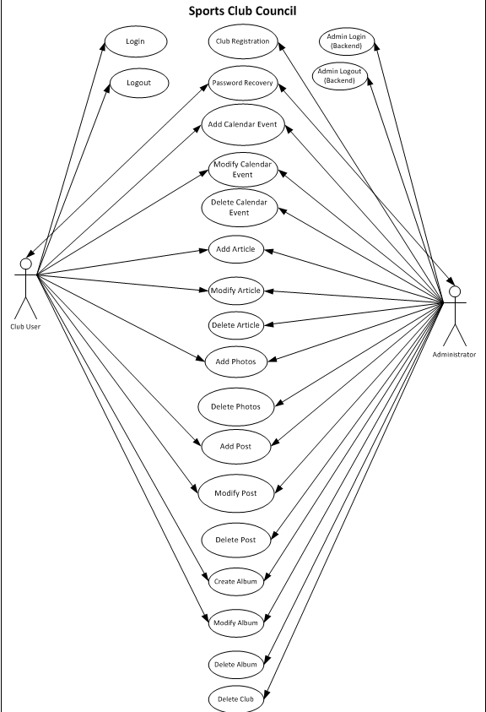
8.2 Sequence Diagrams
N/A

9. Updated Schedule
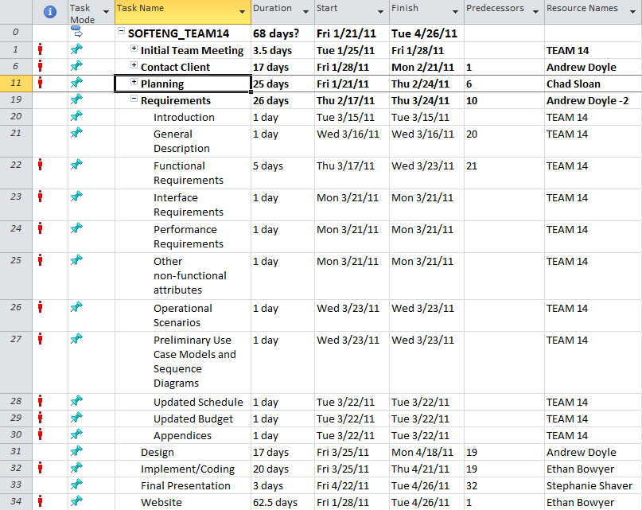

10. Updated Budget
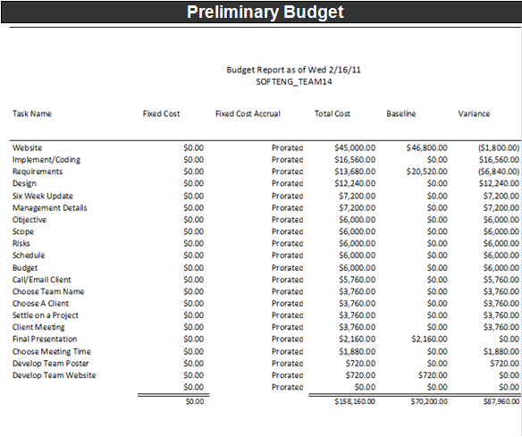
11. Appendices
11.1 Definitions, Acronyms, Abbreviations
Provides definitions of unfamiliar definitions, terms, and acronyms.
Joomla! – Content Management System that we are using to develop the website for our client.
MySQL – My Structured Query Language
We use users and clubs interchangeably
11.2 References
http://www.recsports.vcu.edu/sport_clubs.html -VCU Sports Club Council
http://studentorgs.unc.edu/scc/ -UNC Sports Club Council

